**NBA Draft Combine Measurement**

*Wireframe Documentation*

Homepage

As per the problem statement, we have divided analysis into three sections: -

**Year Slicer:**

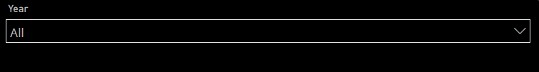

**Count of Players:**

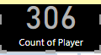

**Year Player**

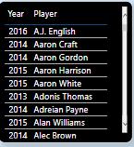

**Average Height (with shoes) and height (without shoes) by year:**

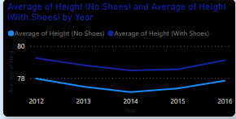

**Count of Hand (no shoes) and hand (with shoes) by year:**

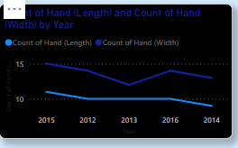

**Count of Vertical (No step Reach) and vertical (No step) by year**

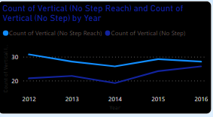

**Count of weight by year**

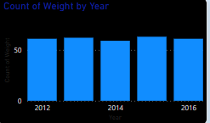

**Height(with shoes) and Weight by year**

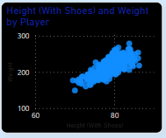

**Player Details**

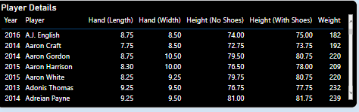

**Average Body fat by year**

